

Course program

AOTrauma Course—Principles in Operative Fracture Management

Course: March 15-17, 2016, TBD, Israel

Online follow-up:

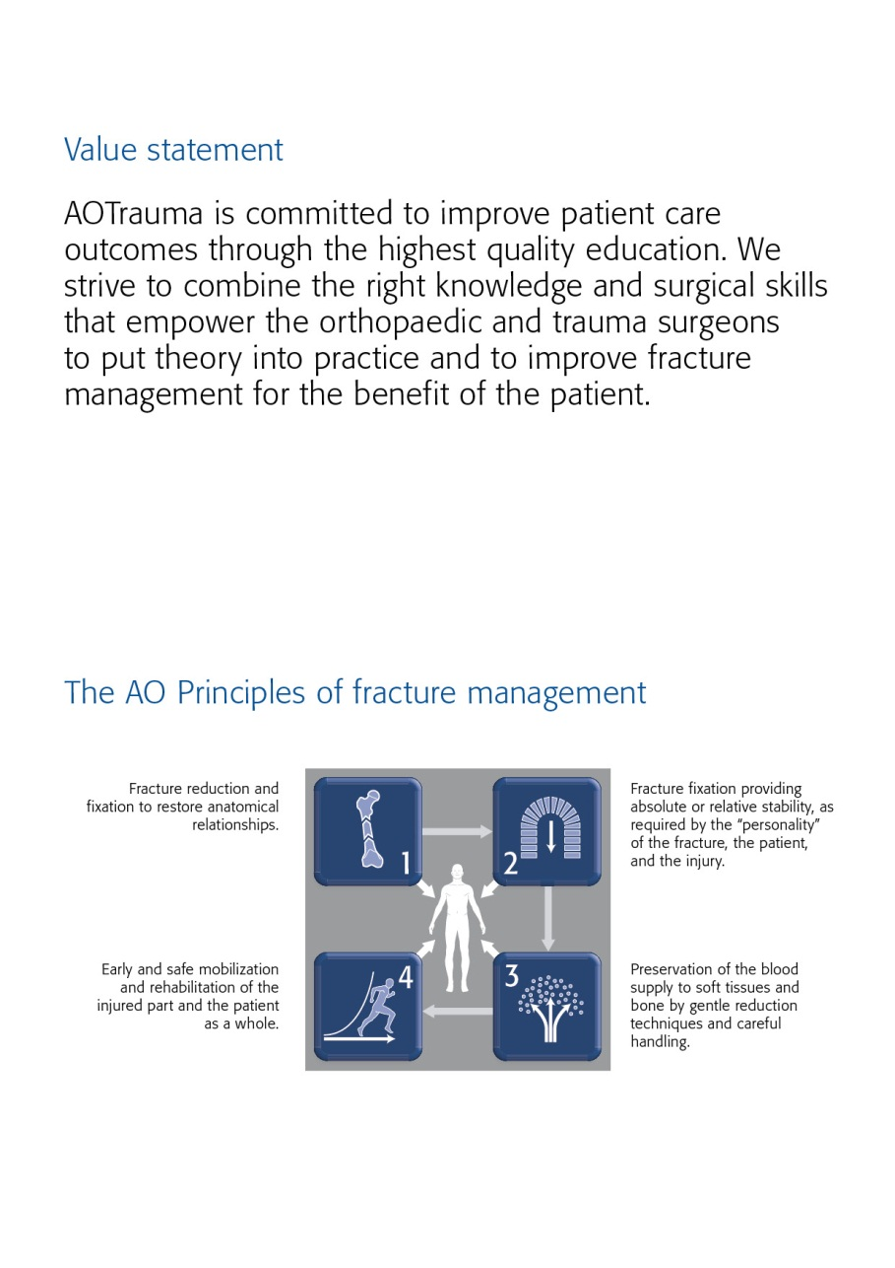

Goal of the course  
The AOTrauma Course—Principles in Operative Fracture Management emphasizes basic principles in operative treatment of the most common human fractures based on application of the AO Principles. This course is the initial step along the path of lifelong learning in the area of operative fracture management.

Target participants  
The AOTrauma Course—Principles in Operative Fracture Management is targeted at doctors in surgical training who are interested in furthering their knowledge and skills in operative fracture management.

Course objectives  
At the end of this course participants will be able to:

* Understand the concepts of stability, their influence on bone healing, and how to apply implants to achieve

appropriate stability

* Plan a treatment based on assessment, imaging, classification, and decision making
* Apply reduction techniques in fracture management with attention to the importance of soft tissue
* Treat fractures using different application techniques
* Evaluate and recognize the special problems related to fractures in the immature skeleton, pelvic injuries, osteoporotic fractures, postoperative infection, and delayed union and/or nonunion

Course description  
Online precourse self-assessment prepares participants for the course and allows the Faculty to tailor the course to the participants' needs.

Before attending the course, participants are also expected to complete two online modules on bone healing and fracture classification.

The live course is taught in a modular format. Evidence-based lectures cover the key information required. Discussing cases in small groups reinforce understanding of the AO Principles and help participants to hone their decision-making and management skills. In practical exercises participants acquire the necessary skills for the application of various techniques. During the playground workshop participants learn about the principles of fractures and test fracture management options.

After the live course an online postcourse self-assessment provides participants with important feedback on how much they have learned.

Chairpersons

* 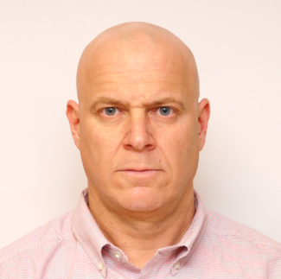*

**Amal Khoury Nir Cohen**

Jerusalem, Israel Tel-Aviv, Israel

[akhoury@hadassah.org.il](mailto:akhoury@hadassah.org.il) nirdoc@yahoo.com

Faculty

|  |  |  |
| --- | --- | --- |
|  |  |  |
|  |  |  |
|  |  |  |
|  |  |  |
|  |  |  |
|  |  |  |
|  |  |  |
|  |  |  |
|  |  |  |
|  |  |  |
|  |  |  |
|  |  |  |
|  |  |  |
|  |  |  |
|  |  |  |
|  |  |  |
| International Faculty |  |  |
|  |  |  |
|  |  |  |
|  |  |  |

|  |  |  |  |
| --- | --- | --- | --- |
|  |  |  |  |
|  |  |  |  |
|  |  |  |  |
|  |  |  |  |
|  |  |  |  |
|  |  |  |  |
|  |  |  |  |
|  |  |  |  |
|  |  |  |  |
|  |  |  |  |

Tuesday, March 15 ,2016

**Lecture hall:**

|  |  |  |
| --- | --- | --- |
| Time | AGENDA ITEM | WHO |
| 08:00–08:30 | Registration of participants |  |
| 08:30-08:45 | Welcome and introduction to the course | Amal Nir |
| **Module 1** | **Injury pattern (soft and hard tissue) and the biology of bone**  At the end of this module, participants will be able to:   * Outline the AO Principles of fracture management * Explain the biology of fracture healing and how it is affected by fracture treatment * Describe the importance of soft tissues in fracture healing * Use the AO Classification to describe a fracture * Define absolute and relative stability and describe their effect on fracture healing | Moderators: |
| 08:45–09:00 | History Of Fracture Care – The AO philosophy |  |
| 09:00–09:15 | Bone Healing – Nature VS Surgeon |  |
| 09:15–09:30 | The soft-tissue injury: Does it matter? |  |
| **09:30-10:00** | **Coffe Break** |  |
| 10:00–10:15 | Müller AO Classification of fractures—long bones—review of eLearning activity |  |
| 10:15-10:30 | Review of learning outcomes of precourse eLearning module: The biology of bone healing |  |
| **Module 2** | **Stability and biomechanics**  At the end of this module, participants will be able to:   * Describe how stability affects bone healing * Distinguish between absolute and relative stability * Describe the types and purposes of surgical screws and their design considerations * Explain the principles and steps of the lag screw technique * Understand the concept of the locking internal fixator | Moderators |
| 10:15–10:30 | Biomechanics—techniques of absolute stability (screws, plates, and tension band principles) |  |
| 10:30-10:45 | Biomechanics—techniques of relative stability (intramedullary and extramedullary splinting) |  |
| 10:45-11:00 | Locking compression plate (LCP) Why/When/How |  |
| 11:00-13:00 | "AO Skills Lab  1. Fracture healing (12') - Weil  2. Mechanics of plate fixation (part 1) (12')- Shadmi  3. Mechanics of plate fixation (part 2) (12')- Aker  4. Mechanics of intramedullary fixation (12')-Bloom  5. Mechanics of bone fractures (12')-Tytion  6. Techniques of reduction (12')-Peled  7. Torque measurement of bone screws (12')-Kish  8. Soft tissue penetration during drilling (12')- Ben -Lulu  9. Heat generation during drilling (12')-Benedict  10. Difficult implant removal (12')- Luria |  |
| 13:00-14:00 | LUNCH | Lunch |
| 14:00-15:00 | **Discussion group 1**  **AO Classification Concepts of stability, their influence on bone healing, and how to apply implants to achieve the appropriate stability**  LOCATION  Group 1  Group 2  Group 3  Group4 |  |
| 15:00-15:05 | **Location change practicals** |  |
| 15:05-16:10 | **Practical exercise 1  Internal fixation with screws and plates—absolute stability** |  |
| 16:10-17:20 | **Practical exercise 2  Principle of the internal fixator using the LCP** |  |
| 17:20-17:40 | Coffe Break |  |
| **Module 3** | **Surgical treatment of diaphyseal fractures**  At the end of this module, participants will be able to:  Describe the treatment goals for diaphyseal fractures  Determine the type of reduction and stability needed for diaphyseal fractures  Prioritize the soft-tissue injury in relation to the “personality of the fracture” | Moderator: |
| 17:40-17:55 | Principles of diaphyseal fracture management—what is important in treating these fractures? |  |
| 17:55-18:10 | Reduction techniques of diaphyseal fractures—principles and methods |  |
| 18:10-18:25 | Fractures of the humeral diaphysis |  |
| 18:25-18:40 | Fractures of the femoral diaphysis (including subtrochanteric fractures) |  |
| 18:40-18:55 | Fractures of the tibial diaphysis- is there a place for a plate? |  |
| 18:55-19:00 | Location change discussion groups |  |
| 19:00-20:15 | **Discussion group 2**  **Management principles for the treatment of diaphyseal fractures**  Group 1  Group 2  Group 3  Group4 |  |
| 20:15 | **End Day 1** Faculty meeting |  |
|  |  |  |

Wednesday 16, 2016  
**Lecture hall:**

|  |  |  |
| --- | --- | --- |
| Time | AGENDA ITEM |  |
| **08:00-09:15** | **Discussion group 2**  **Management principles for the treatment of diaphyseal fractures**  Group 1  Group 2  Group 3  Group4 |  |
| 09:15-09:25 | Location change practicals |  |
| 09:25-10:55 | **Practical exercise 3**  **Tibial fractures—intramedullary nailing with the expert tibia nail (ETN) (with reaming** |  |
| 10:55:11:15 | Coffe Break |  |
| **Module 4** | **Management of articular fractures of the upper extremities**  At the end of this module, participants will be able to:   * Describe the treatment goals for articular fractures * Determine the type of reduction and stability needed for articular fractures * Outline the function and clinical indications for the tension band technique * Apply key surgical principles to the management of articular fractures | Moderator: |
| 11:15-11:30 | Management principles for articular fractures—how do they differ from diaphyseal fractures? |  |
| 11:30-11:45 | Reduction techniques for articular fractures—principles and methods |  |
| 11:45-12:00 | Forearm fractures—not just another shaft fracture |  |
| 12:00-12:15 | Fractures of the olecranon and patella : is tension band technique a panacea? |  |
| 12:15-12:30 | Proximal humeral fractures—When doe operative treatment make sence? |  |
| 12:30-12:45 | Are children small adults? |  |
| 12:45-14:15 | Lunch |  |
| **Module 5** | **Surgical management of articular fractures of the lower extremities**  At the end of this module, participants will be able to:   * Describe the anatomy, physiology, and response to injury of articular segments * Recognize the need for anatomical reduction of the joint * Name the reduction techniques and explain when direct and indirect methods are used | **Moderator:** |
| 14:15-14:30 | Femoral neck fractures |  |
| 14:30-14:45 | Trochanteric fractures |  |
| 14:45-15:00 | Distal femoral fractures—management principles |  |
| 15:00-15:15 | Tibial plateau fractures |  |
| 15:15-15:30 | Distal tibial fractures |  |
| 15:30-15:45 | Ankle fractures—a logical approach for their fixation |  |
| 15:45-16:45 | **Practical exercise 4 (part 1)**  **Preoperative planning—plan your ANKLE operation** |  |
| 16:45-17:45 | **Practical exercise 4 (part 2)**  **Operate your plan— Management of a malleolar type 44-C fracture** |  |
| 17:45-18:00 | **Cofee break** |  |
| 18:00-19:30 | **Discussion group 3**  **Articular fractures—principles and synopsis**  Group 1  Group 2  Group 3  Group4 |  |
| 20:30 | Galla |  |

Thursday, March 17, 2016  
**Lecture hall:**

|  |  |  |
| --- | --- | --- |
| Time | AGENDA ITEM | WHO |
| 08:00-09:30 | **Practical exercise 5**  **Management of a trochanteric fracture using a PFNA** |  |
| 09:30-09:45 | Change location discussionroom |  |
| 09:45-11:00 | **Discussion group 4**  **Multi trauma—principles and synopsis**  Group 1  Group 2  Group 3  Group4 |  |
| 11:00-11:20 | Coffe Break |  |
| 11:20-12:00 | "Practical exercise 6  Tibial fractures treated with different external fixator frame constructs—assessment of stability  • Video: 00135  • Bone model: 1118" |  |
| 12:00-13:15 | "Practical exercise 7  Stabilization of the pelvic ring using a large external fixator  • Video: 00122  • Bone model: 4083" |  |
| 13:15-14:30 | Lunch |  |
| **Module 6** | **Special issues and problems**  At the end of this module, participants will be able to:   * Describe and understand the dangers of radiation and how to avoid them * List the causes and factors that lead to postoperative infection * Name factors leading to delayed union and/or malunion | Moderator: |
| 14:30-14:45 | Radiation hazards |  |
| 14:45-15: 00 | Treatment algorithms for the polytrauma patient |  |
| 15:00-15:15 | Emergency management of pelvic fractures—a critical skill can save lives |  |
| 15:15-15:30 | Treatment principles of Open Fractures |  |
| 15:30-15:45 | Infection after osteosynthesis—how to diagnose and manage? |  |
| 15:45-16:00 | Non-unions causes and treatment |  |
| 16:00-16:20 | Coffe Break |  |
| 16:20-17:20 | **Practical exercise 8**  **Tension band wiring of the olecranon** |  |
| 17:20-17:30 | Location change lecture |  |
| 17:30-18:00 | The Future of Orthopedic Trauma Care |  |
| 18:00-18:15 | Take-home messages from the course participants |  |
| 18:15-18:30 | Closing remarks |  |
| 18:30 | **End of Course** |  |
|  |  |  |



AOTrauma Clavadelerstrasse 8, 7270 Davos Platz, Switzerland

Phone +41 81 414 27 20, F +41 81 414 22 84, courses@aotrauma.org

Logistics and support provided by an educational grant from DePuy Synthes.